Завдання з англійської мови
9 клас
Вересень 2013

Учитель: Мандрика О.Ю., Шостаківський НВК

Listening
The KIPP Academy
Donna Smith takes a look at an educational revolution

New York's South Bronx district suffers terrible social problems, such as widespread illiteracy, drug abuse and youth crime. But in the midst of this, there is a school which has produced surprising academic results by combining lessons in hip-hop with the long hours and work ethic of the Victorians.
The KIPP Academy has been the best public middle school in the South Bronx in reading, math and attendance for nine consecutive years, and ranks in the top ten per cent of all New York City public schools.
KIPP stands for the Knowledge is Power Programme, a national network of free co-educational public schools in poor communities throughout the USA. There are over fifty KIPP schools serving 14,000 students in seventeen states. More than eighty per cent of them are low-income, and more than ninety-five per cent are African American or Hispanic/Latino. 'KIPP aims to provide underserved students the same» quality of instruction found in a top state-run Academy in Europe,' explains KIPP spokesperson Steve Mancini, who taught English at the Second Liceum in Gliwice, Poland in 1990-91 through the World Teach Program. The idea is that everyone should have the opportunity to obtain the academic and character skills necessary to achieve success, so students are accepted regardless of background or academic record. Amazingly, nearly eighty per cent of them end up graduating from high school and going on to college!
The secret to KIPP's academic success is hard work. The school day lasts from 7:25 a.m. to 5:00 p.m. every weekday, plus, four hours on Saturday and three weeks during the summer holidays. That amounts to fifty per cent more classroom time than in traditional public schools.
The students' progress is closely monitored and they get a lot of support. They can phone their teachers if they have problems with their homework, and the school constantly communicates with parents about how they can help their children at home, і
Another reason why KIPP is successful is the 'joy factor'. The teachers are hardworking, creative and motivating, and they use techniques such as singing, chanting, and movement to make lessons fun and engaging. A unique feature at the South Bronx KIPP school is the 180-piece orchestra, whose purpose is not to train professional musicians, but to show what can be achieved through enthusiasm and hard work. Students can take part in extra-curricular activities such as Art, Physical Education and Business Studies, and there are also regular field trips all around the country.
The result is that very few students skip classes, cheat in exams or drop out. At KIPP, they help children become better citizens as well as better learners. They measure success not only by higher test scores, but also by what kind of citizens their students become. The philosophy is simple: “Work Hard, Be Nice”.

1. Listen the text about a special school in New York. Decide if the statements 1-6 are true (T) or false (F).
1. The KIPP Academy is the best public school in New York.
2. Most students at the KIPP Academy come from poor families.
3. Most students continue their education after finishing the KIPP Academy.
4. One reason why students are successful is that they have more lessons than in other schools.
5. All students at the KIPP Academy have to study Art.
- There are no discipline problems at the KIPP Academy.

2. Listen the text again. Find at least seven things that make the KIPP Academy a success.
- school day from 7:25a.m to 5:00p.m every weekday plus four hours on Saturday
-

Reading

FROM "THE MOST DANGEROUS GAME" by Richard Connell
Glossary: forged — просуватися повільно bluff— стрімкий берег
Bleak darkness was blacking out the sea and jungle when Rainsford sighted the lights. He came upon them as he turned a crook in the coast line; and his first thought was that he had come upon a village, for there were many lights. But as he forged along he saw to his great astonishment that all the lights were in one enormous building — a lofty structure with pointed towers plunging upward into the gloom. His eyes made out the shadowy outlines of a palatial chateau; it was set on a high bluff, and on three sides of it cliffs dived down to where the sea licked greedy lips in the shadows.
"Mirage," thought Rainsford. But it was no mirage, he found, when he opened the tall spiked iron gate. The stone steps were real enough; the massive door with a leering gargoyle for a knocker was real enough; yet above it all hung an air of unreality.
He lifted the knocker, and it creaked up stiffly, as if it had never been used before. He let it fall, and it startled him with its booming loudness. He thought he heard steps within; the door remained closed. Again Rainsford lifted the heavy knocker, and let it fall. The door opened then — opened as suddenly as if it were on a spring — and Rainsford stood blinking in the river of glaring gold light that poured out. The first thing Rainsford's eyes discerned was the largest man Rainsford had ever seen — a gigantic creature, solidly made and black bearded to the waist. In his hand the man held a long-barreled revolver, and he was pointing it straight at Rainsford's heart.

Questions 1 through 5 (on your answer sheet circle the correct letter a, b, c, or d)
1. Rainsford saw so many lights and he thought he had come upon...
- a village.
- a city.
- a large house.
- a palace.

2. Which of the following words would describe the knocker on the door?
a) old
b)new
- soft
- wooden

3. Rainsford compared the light that poured from inside the house to
- a light as bright as a shining star.
- a river of glaring gold light.
- a golden light that shone through the dark jungle.
- the first sunlight that greets us in the morning.

4. The author does NOT use the following word to describe the man who greets Rainsford.
- gigantic
- solid
- legendary
- black bearded

5. Which of the following objects did the man at the door hold in his hand?
- a revolver
- a sword
- a stick
- a candle
Speaking

You are attending a language school in England and you are planning a class trip. Below you will find some pictures of places where you could go. Your teacher wants to go to the National Gallery in London, but you think it is boring. Persuade your teacher to go to one of the other places.

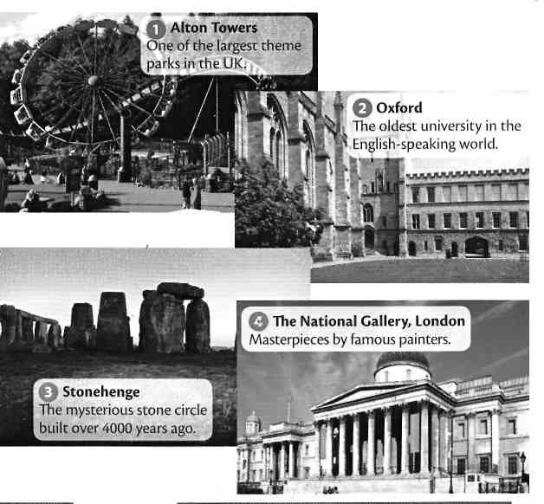

Writting

You would like to go on a summer English course in Cambridge. You have found an advertisement for a language school that looks interesting. Write an email to the manager of the school in which you will ask about:
- the price of a one-month General English course
- the facilities at the school
- afternoon activities

You would like to take part in a windsurfing course in Australia. You have found the website of a company that organizes such courses. Write an email to the manager of the company in which you will ask about:
- enrollment requirements
- the price of a two-week course
- accommodation

Your friend wants to visit London soon, but he (she) doesn’t have a car. Write some advices to him (her) about public transport in London:
- key routes and tourist attractions in central London

Let’s imagine that many people have fallen ill in the city where you live due to the high number of cars in town that are creating air pollution.
- What would you suggest be done about this problem?
- How do you think people of your town will respond to limitations on car use?
- How practical do you think bicycle riding is as an alternative to car driving in Ukraine?

